Alaska Indoor Gardening Curriculum

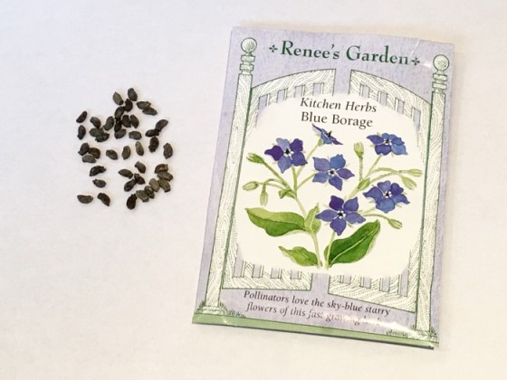
Reading a Seed Packet

Author/Source: Patrick R. Ryan, Alaska Botanical Garden and Melissa Sikes, Fairbanks Soil and Water Conservation District

Suggested Grade Levels: All

Time: 45 minutes for one session.

Teaching Goals:
To learn how to read a seed packet.
To have students search and find important information in a real world situation.

Learning Objectives: Students will learn how to read a seed packet and understand the needs of different kinds of plants, and planting requirements for seeds.

Core Ideas:
- Reading and Comprehending Scientific Technical Information
- Venn Diagrams
- Plant Life Cycles
- Plant Light and Soil Nutrient Needs
- Horticulture
- Germination
- Propagation
- Recording Scientific Data
- Drawing Conclusions from Experimentation

Alaska Science Standards:
K-LS1-1, 1-LS1-1, 2-LS2-1, 3-LS4-4, 4-LS1-1, 5-LS1-1, MS-LS1-5, HS-LS1-2

NGSS Standards
K-LS1-1, K-ESS2-2, K-ESS3-1, 1-LS1-1,2-LS2-1, 3-LS3-1, 4-LS1-1, 5-LS1-1, MS-LS2-1, HS-LS2-2

Materials Needed:
- Seeds - a wide variety of different types of seed packets
- Magnifiers
- Seed Packet Investigation Worksheet
- Pencils
- White or blackboard or chart paper and markers to write.
- 2-3 hula hoops to make a Venn Diagram on the floor, or masking tape.

Vocabulary:
- Annuals - Plants that perform their entire life cycle from seed to flower to seed within a single growing season. All roots, stems and leaves of the plant die annually.

- Biennials - Plants which require two years to complete their life cycle. First season growth results in a small rosette of leaves near the soil surface. During the second season's growth stem elongation, flowering and seed formation occur followed by the entire plant's death.

- Germination: Germination is the process by which the seeds begin to grow into the plant.

- Perennials - Plants that persist for many growing seasons. Generally the top portion of the plant dies back each Winter and regrows the following Spring from the same root system.

- Propagation - to produce a new plant from a parent plant.

Background for Teachers: This lesson will explain how read a seed packet. Seeds can be rather finicky if not prepared or planted correctly so it is important to follow the directions on each packet. There is a lot of information include within the body of this lesson. You can choose which information is appropriate for the age of your students and what might be overwhelming. Student interest could also drive the discussion. There’s no need to go over everything included in “teacher information” below, but it’s there if you choose to use it.

Most seed companies offer good information right on the outside of their seed packets (or sometimes inside). Learn to read and understand the specific needs of whatever you’re planting BEFORE you get out into the garden. Look at your seed packets well before the suggested planting time in your area to familiarize yourself with that seed’s requirements. Winter is a great time to do your planning and to dream of gardens. You can make labels then and do some garden design too.

If you have saved any seeds from the last growing season, they are probably good. Most seeds are viable up to 3 years. Onions, parsley, lettuces, larkspur and delphinium do not always carry over so they are best purchased fresh each year.

Once spring arrives, remember: DON’T PLANT THE WHOLE PACKET! There may be anywhere from several hundred to a thousand seeds in each packet! You do not need 50 tomato plants! Seed catalog sites will suggest that if you are starting seeds indoors, you should count backwards from your last frost date to plan when your new seedlings can go outside into the garden or container. Johnny’s Select Seeds has a great planting chart. Just type in your last frost date here: www.johnnyseeds.com Look under: InteractiveTools_122014).
Many other seed companies have similar charts. Many suggestions about choosing and planting seeds can be found at Renee’s Garden website: https://www.reneesgarden.com/blogs/gardening-resources/

Procedure:
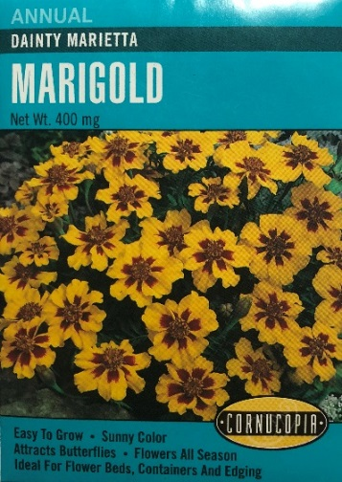
- Explain that you will be exploring seed packets today. Show the seed packets and ask the students what information they might find on the packet. If they are stumped, give them an example: vegetable or flower, annual or biennial or perennial, etc. Try to elicit as many ideas from the students as possible and list them on the board or chart paper.

- Then let them choose a seed packet of the plant they are interested in learning more about and have them bring it back to their desk or work area. Consider having students work as pairs for this section of the lesson. Students working in pairs will need fewer packets which will be easier for you to manage and gives them someone to speak to about their ideas and hopefully self-correct.

- Ask the students what other information they see on their packet. Add the terms to the list you started at the beginning of the lesson. If a student points out something that is variable, stop and ask the students if everyone has that on their packet. For example, some packets have a photo of their plant and others have an illustration. Another example is some suggest a schedule for indoor planting ahead of time, and others recommend sow directly into ground after the last frost.

- Make sure you have a few seed packets that have the information placed in different locations available to model differences to the students. You may want to use a document camera or project a photo so that the entire class can see the examples you are using.

- Start with the front of the package. Ask what sticks out to them about the front of the package. What would draw them to plant this particular plant? Point out the illustration/photo of the plant and that this to the list on the board if it isn’t already there.

- Ask the students what else they see on the front of the package. Who is the Seed Company? List the different seed companies of the packets you brought on the board.
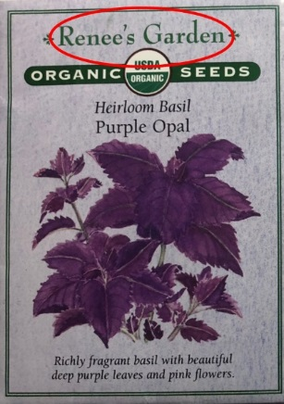
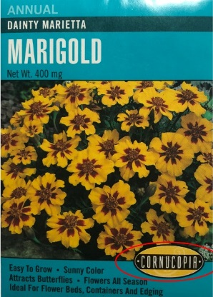

- Then look for the type of the plant you would be planting. Usually it is the largest text on the package, but not always. Add “plant type” to the board. Ask students what plant they have chosen, but don’t add the names of the plants to the board.
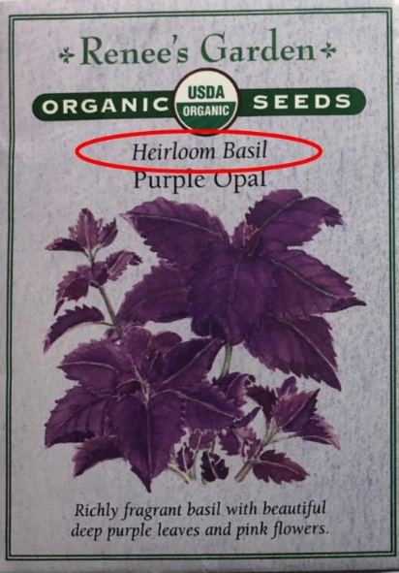
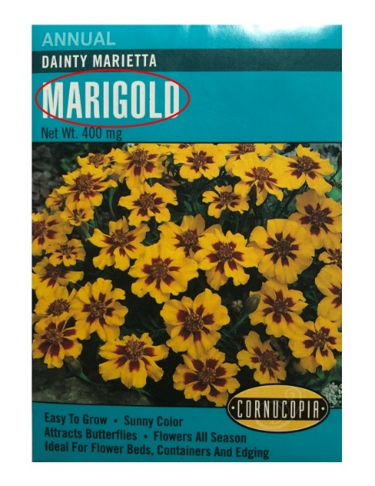

Marigold Heirloom Basil

- Define the words annual, perennial, and biennial. If appropriate for your grade level, review or teach what the root prefixes are. Ask students what the varieties are that they have chosen. Is it an annual or a perennial? Explain what a variety is? Emphasize the descriptive nature of the variety names.

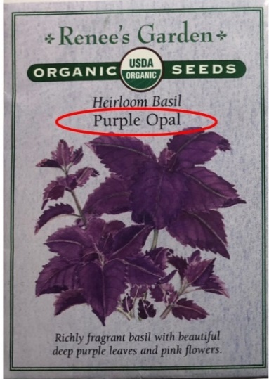
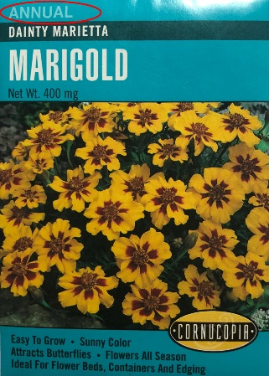

Teacher Information
Plant Variety and Type:
On the front of the seed packet, it will tell you the variety or cultivar. For example: there is more than one kind of tomato and the variety is very important both for taste and hardiness. On flower seed packets it will also state whether they are an annual, perennial, or biennial. This could be important if you are planting the seeds for an outdoor garden as some plants can take multiple years to bloom.

- Look for the other miscellaneous information about the plant on the front. Add terms to the board. Possible terms include organic, color, butterfly attracting, etc.
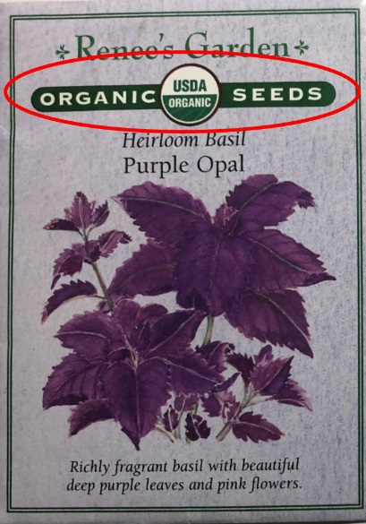
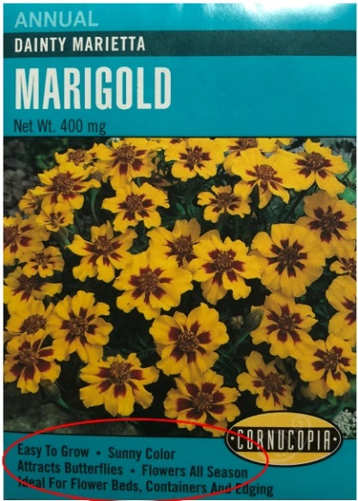

Easy to Grow, sunny color, Certified Organic
attracts butterflies, etc.
Teacher Information
USDA Organic: This means that the plant that the seed came from was grown under the standards required to be certified by the USDA as organic, therefore making the seed itself organic. It also means that the seed could not be treated with any substances that would make it ineligible for the organic certification. Some non-organic seeds are sold treated or coated.

- Then look at the back of the package. This is where a treasure trove of information is located. Give student groups time to examine the back. If appropriate, ask them to make a small list of items they think belongs on the board with the other terms.
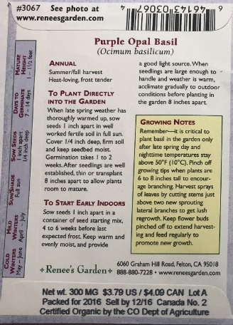
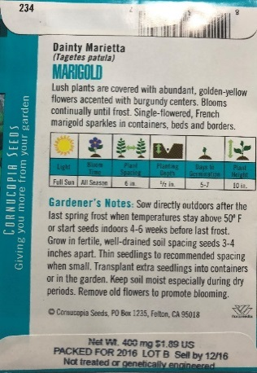

Teacher Information
Description: Somewhere on your seed packet you will find a description that gives you the specific characteristics of the cultivar/variety. Some packets will have a nice paragraph like you see on the marigold, others will just have a few lines. It should give you an idea of the color of the mature flower or vegetable (if that’s important) and the taste, growing and/or storage characteristics. Basically, whatever makes this plant different than others.

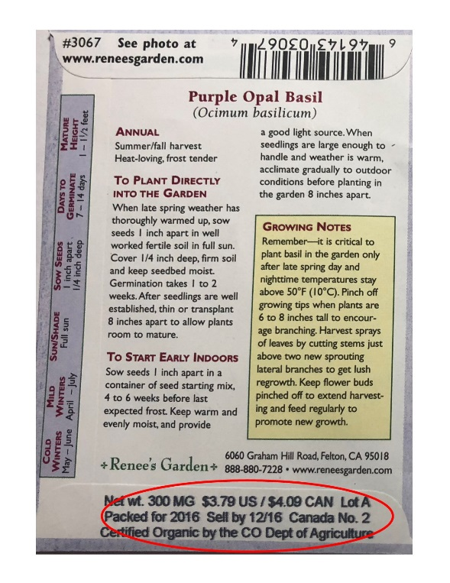
Date for Freshness: Look for the date of the seed packet, generally on the back or at the bottom. This is similar to the “sell by” date on your milk, or your canned goods. The Federal Seed Act in the United States sets germination standards for vegetable seeds in interstate commerce. The company is basically promising that as long as the seed is sold by the date specified that it will meet those germination standards. Remember that seeds are generally good for several years, although some varieties do not keep well. If the seeds have been kept cool and dry, they are generally okay to plant. If you have old seeds or if you have saved them from last year, you may want to test them first. Place ten seeds rolled up in a moist paper towel. Place in a small plastic bag and keep in a warm place. Check after a few days. If five or fewer seeds sprout, the germination rate is poor. If all ten sprout, that’s 100%, and you can plant those seeds
and the ones in the packet. Packed for 2016.

Propagation: How to start the plant. It will tell you if you can start it ahead of time in pots (some plants DO NOT like to be transplanted) and how long before it can be planted outside you can do that. It will give a suggestion of when the plant can be planted outside. If it says “direct sow” it generally means plant once, in the spot you wish it to grow. Things like carrots do not like to be transplanted. If it says “start indoors 6-8 weeks before the last frost” and you know that you typically plant outside after Memorial Day, calculate backwards approximately when to plant your seeds. There is no harm in planting things like tomatoes and peppers early, but other things like leafy vegetables really prefer the shorter indoor growth time. Occasionally you will see something like “plant in fall before the frost” This doesn’t generally work for most places in Alaska, just be patient and wait until spring.

- Add description, propagation, and date for freshness on the board. Ask Students what their packets say. You can do it as a round table, volunteer, or survey style and ask students to raise their hands. The goal is to get the students to find the information and share it. This way you can check if they are still with you.

- Ask the students to find the planting detail panel. You may want to show them the example below or an example on your packets. Directly show them that the panel gives specifications for physically growing the seed. After, ask them which terms to add to the board. Encourage them to identify these terms: sun or light requirements, number of days to bloom or harvest, plant spacing, planting depth, preparation of seeds, height of plant, maturity.

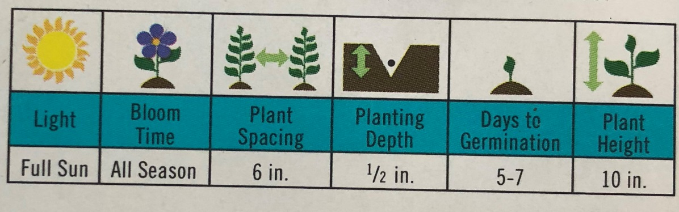

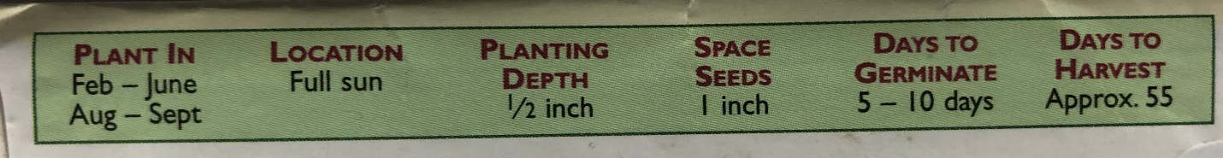

Teacher Information
Sun/Light/Location: This tells generally how much sun the plant requires. Full sun is considered 8 full hours without shade. Partial sun and shade are the other normal designations. In general you can assume that vegetables which produce fruit are going to need full sun, leafy items might be ok in partial shade. Not much edible grows in full shade.

Number of Days to Bloom/Harvest: Somewhere on the packet it will tell you how long the plant will take to mature. This means a full blossom for a flower, or an edible fruit for a vegetable. This is an approximate number to help in your harvest planning. Weather, temperature, and watering can affect the time suggested. Seed catalog sites will suggest that if you are starting seeds indoors, you should count backwards from your last frost date to plan when your new seedlings can go outside into the garden or container.

Plant Spacing: For every plant there is an optimum amount of space for them to grow in where they will not only have the physical room they need to spread out (both above and below the soil) but also have enough soil around themselves to provide the water & nutrients they need. Sow small seeds thinly to give the tiny plants room to grow until they are strong enough to transplant to larger containers or into the garden. Generally, a one-inch spacing seems to work for the many greens that can be grown. If you crowd them too closely certain plants will not really produce for you. This seems to be especially true for root vegetables like carrots, which need the room.

Planting Depth: How deep should you place the seed. A general rule of thumb is to plant the seeds twice as deep as their size. Cover if required and press down gently for good seed-to-soil contact. Note: some seeds require light to germinate. “Some, but not all, popular seeds which prefer light for germination are: Achillea, Alyssum, Antirrhinum, Begonia, Calceolaria, Coleus, Exacum, Ficus, Gaiilardia, Gerbera, Gloxinia, Helichrysiim, Kalanchoe, Nicotiana, Petunia, most Primula, Saintpauliu and Streptocarpus.” (Source of article Growing From Seed - Spring 1989 Vol. 3 Number 2 © The Seed Raising Journal from Thompson & Morgan). See also The New Seed Starters Handbook by Nancy Bubel for some great information on starting your own seeds.

Preparation of Seeds: Some seeds do better if scarified, which means lightly scratching the seed coating, which helps the seed break through it’s hard outer coat. Some common vegetables like squashes germinate better if their seeds are scratched or nicked before planting. Others prefer to be soaked for a few hours to soften the hard seed coating, like nasturtium and peas. Some seeds also prefer to travel through the digestive system of a bird or animal before germination, like strawberries, blackberries and other fruits. You can rub them on an emery board lightly on the flat side and the edges. Soak peas, beets, and nasturtiums for a few hours before planting. Scarification isn’t always necessary as a cold spell is for some plants, but you’ll have better germination if you do it.

Days to Germination: This is an approximate number. Seeds generally need to be kept moist while they are germinating, or “waking up”. If nothing green comes up after a week or so beyond the expected germination date, you may want to replant your seeds. Ed Hume Seed Company suggests some possibilities for poor germination: “Seeding too deeply, planting in cold soil, extremes of watering, improper soil preparation, birds or squirrels and poor seed are the most common causes for seeds failing to germinate.”

Plant Spacing After Thinning: The standard method of planting is to plant more seeds in the ground than you need in case some don’t come up, then to “thin” your plants down to the recommended spacing. You thin by either pulling up or cutting off the plants you don’t need Some people have trouble with this-it seems criminal to kill a perfectly healthy little plant. Be strong-your remaining plants need that room!

Height of Plant: An approximate number for planning the height of a mature plant in the garden or a container. Generally , tall plants go on the back of the garden so they do not shade the smaller plants. In a container, tall plants would go in the middle if the container is to be viewed from many angles. This might be important for shelf spacing for indoor gardening to be sure the plants to push up against the shelves above them as they grow.

Maturity: Many seed packets will give an approximate number of days to harvest or maturity which is when you can expect edible vegetables or mature flowers. This is very important for those with short growing seasons. This helps you to estimate how long it will take and will you be able to harvest before the first frost. It can also help you to calculate when to start your seedlings indoors.

- Direct the student’s attention to a Venn Diagram on the floor made of hula hoops or tape. Explain to the students that you are going to use descriptors and they need to place their packet in the correct circle. If their packet doesn’t meet any criteria, it goes outside of the diagram. Take a few minutes to show the students where to stand. Start by giving them sample questions that are easy.

- Put down the label plant in one circle. Tell the student that the other circle is for packets that don’t grow into plants. Teach the procedure. Give students 20 seconds to think, then count up to three. When you begin to count, students put down their packets and step back. Then you visually check how everyone did and correct anyone who was wrong. Have students pick up their packets.
a. Other “easy” questions are opinion based or color based. Consider asking students for tall and short plants. Plants that are purple/red/or only green. This gives room for students to explain their answers and use the middle of the Venn Diagram.

- Then move on to the more difficult questions such as plant companies, how tall the plants grow, plants that produce a fruit or vegetable. There are labels at the end of this Lesson Plan that you can use to get started with this activity.. This is also where you can use the list you generated with the students on the board. Turn the list into questions to play with on the Venn Diagram. However, consider doing it as an oral listening activity. Students have to pay attention to know where to put their packet.

- Part way through the Venn Diagram activity, consider having students exchange packets with another group and keep going. Emphasize questions that encourage the students to read their packets to find the information. To keep this activity moving quickly, it’s important that the facilitator to be familiar with the seed packets so they can visually check most packets without needing to stop and read all the packets after each prompt.

- When you are satisfied the students are doing well, close the lesson by asking them to put the seed packets on a table in the front of the room and ask them to return to their desks or work area.

- Pass out the Seed Packet Investigation Worksheet. Explain the expectations. You can have students work together again or as individuals. Have students come back to the front and choose a seed packet that is “new to them” to complete the worksheet.

Worksheets:
- Seed Packet Investigation
- Venn Diagram Labels

Extensions:
- Indoor Gardening with Soil Lesson to start planting
- Seed Science Lesson
- Do You Know the Parts of Plants? Lesson
- Individual Plant Parts Lessons

Cross Curricular Ideas:
- Determining how many square feet of ground each seed packet would cover if it was fully planted following the recommendations
- After the above, determining how many acres/miles/square feet the entire class would need to plant all the seed packets or one packet per person.
- Explicitly teach the vocabulary including the prefixes, suffixes, and roots of the gardening words
- Read aloud one of the books (ideas below) and use in a reading center
- Use the seed packet worksheet in a literacy center
- Have students journal in their science journal and reflect on the lesson or what they’ve learned.
- Expand the Venn Diagram on the floor into other subjects and continue to compare and contrast other things.
- Discuss the plants that grow in their local area and the limitations that outdoor gardeners may face. Ask students what local gardeners may be looking for as they seed shop on seed packets.
- Design a seed packet for a “new” plant that contains some of the information they learned about in the day’s lesson. This can be oriented as an artistic opportunity or more of a writing opportunity. But there’s a lot that can be done!

Assessment Options:
- Use the worksheet as a sort of quiz to determine if students can independently find the information
- If using a science journal, evaluate the student’s entry.
- Ask students to write a paragraph(s) using the terms on the chart on the board.
- Develop a checklist to check how students are doing as they proceed through the parts of the lesson. Consider checking off participation, understanding of the Venn Diagram, using the terms, and how they did on the worksheet

References:
Books:
- A Seed Is Sleepy by Dianna Hutts Aston , illustrated by Sylvia Long
ISBN-10: 0-8118-5520-1; ISBN-13: 978-0-8118-5520-4 2007
- From Seed to Plant by Gail Gibbons
ISBN: 0-8234-1025-0 1991
- Gardening Indoors with Soil and Hydroponics by George Van Patten
ISBN: 978-1-878823-32-8
- How a Seed Grows by Helene J. Jordan, illustrated by Loretta Krupinski
ISBN-13: 978-0-06-445107-9; ISBN-10: 0-06-445107-0

Websites:
- KidsKonnect – General Gardening information
https://kidskonnect.com/science/gardens/
- Johnny’s Selected Seeds Growing Center Information
http://www.johnnyseeds.com/growers-library/growing-center.html
- Kids Gardening
https://kidsgardening.org/
- Renee’s Garden Resources
https://www.reneesgarden.com/blogs/gardening-resources

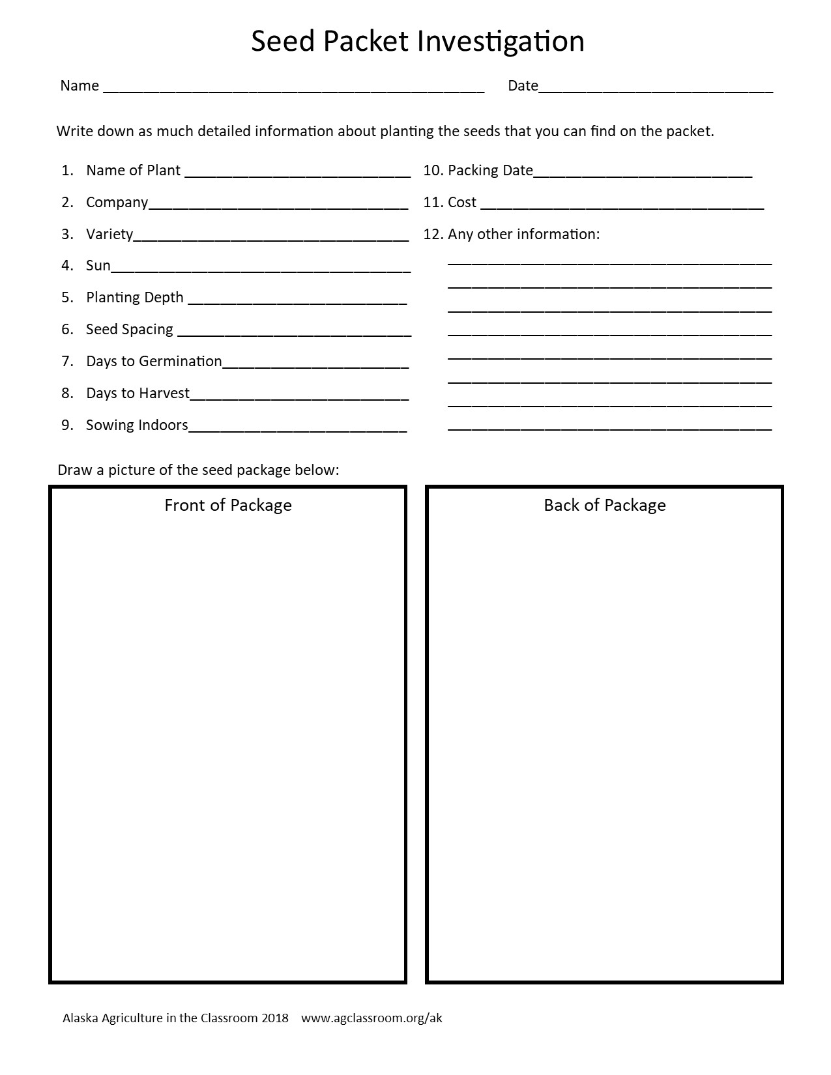
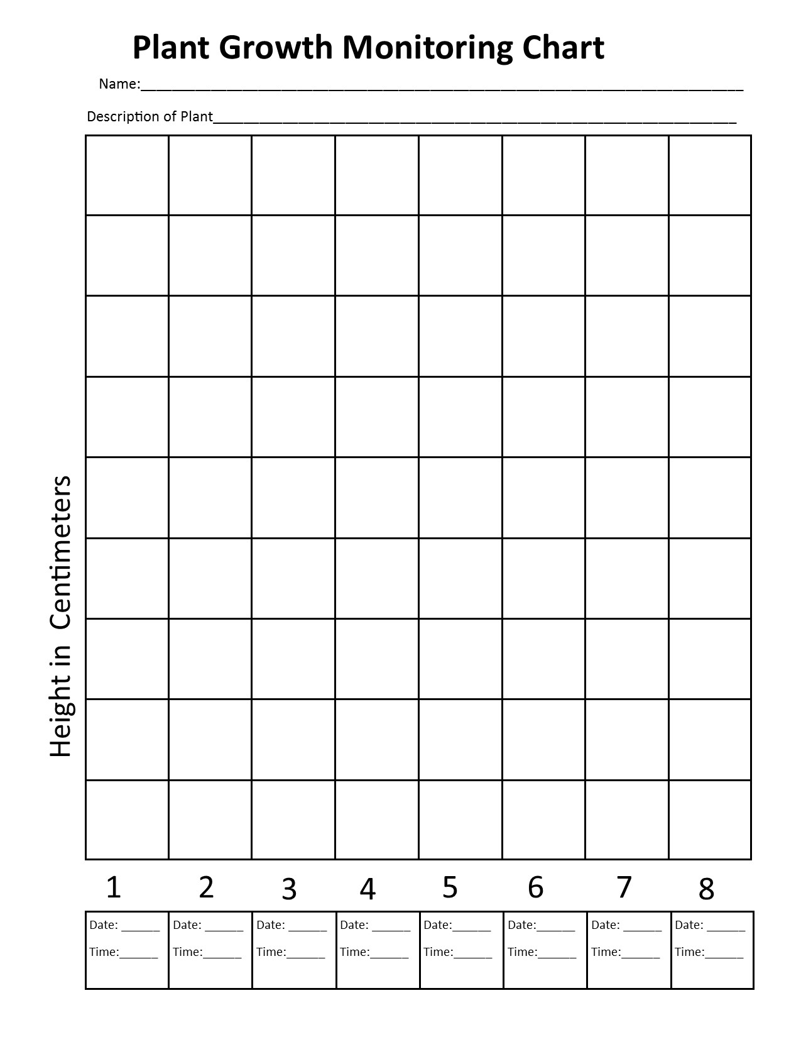
Venn Diagram Labels

Flowers Vegetables Perennial Annual Organic Seasonal 12’’ 6’’ Full Sun Maturity 30 Days 60 Days
90 Days Bloom Fruit Thinning Partial Sun Shade 2’’ Organic Plant Seeds Tall Short Ugly Beautiful

